How to Trim Your Cat's Claws
Regularly trimming your cat's claws is an easy and cat-friendly way to "sharply" reduce the sting from scratching activities. With a little preparation and diligence, claw-trimming can be a simple and pleasant routine.
Preparation
Get your cat used to your handling and gently squeezing her paws. Don't proceed faster than she'll let you; the idea is for her to become comfortable with this. Note: cats are often more agreeable to new things if they get a treat.
In the interim, your vet or a trusted groomer can trim your cat's claws quickly and cheaply, and will usually be glad to show you how.
Step-by-Step Instructions
Start with a relaxed cat, sharp clippers, and a good light source, for best results. Some folks prefer specially made cat clippers (available in pet supply stores), others use regular human nail clippers. Either device works well.
1. Ease into a position that's comfortable for you and your cat. For some, this means kneeling behind kitty, for others this means supporting her in your lap. Calmly talk to her and pet her. You may want to have a treat reward in plain view.
2. If kneeling down behind your cat, secure her gently between your knees, and take a front paw in your left hand. If kitty's in your lap, have her facing to your right, and support her securely in your left arm with her front paw in your left hand. It may be easier at first to wrap her in a towel with only the paw extended. If you're left-handed, use the opposite hand (and face kitty to your left if she's in your lap).
3. With your thumb on top of her paw, and two or more fingers underneath, press gently but firmly on the pad area to extend a claw. It isn't necessary to squeeze hard.
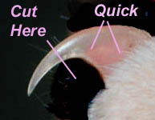
4. Examine the claw closely under light to find the pink area in the
center called the "quick." This is a blood vessel, and will bleed if
nicked.
5. Holding the clippers in your other hand, make sure there' s no
chance that the clippers will catch any of the pad. Then snip off the
tip of the claw, being careful not to cut into the quick (see picture).
6. Give kitty a treat and a few kind words for being such a good cat.
The more relaxed you and she both are, the easier the process will
be.
7. Repeat steps 3 through 6 until you have finished the first paw.
8. If your cat is comfortable and compliant, continue until the nails on both front feet have been clipped. If things are going smoothly, optionally clip the back paws. Don't forget the "dewclaw" on the paw's side.

Tips:
1. Keep some styptic powder or styptic pads handy in case you accidentally cut into the quick. If this should occur, apply the powder to the nail to stop the bleeding, and call it a day.
2. It may be easier if you have a second person holding the cat. Above all, it's important that you and your cat both be relaxed.
3. If at any time your cat becomes anxious, stop immediately. You can do one claw every day, if necessary.

To view the complete collection of Shelter Sheets, visit www.cats.about.com/library/nosearch/blss.htm.
© 2001 by Franny Syufy, licensed to About.com, Inc. Used by permission of About.com, Inc., http://www.About.com. All rights reserved. Ilustration: Max's House (www.maxshouse.com).

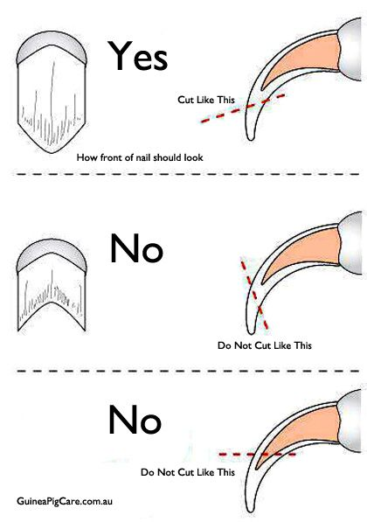
Cats and Claws, Happily Ever After
Trimming
Keep your kitty's claws trimmed. Taking that nail tip off every 2-4 weeks will minimize any damage caused by inappropriate scratching. Since cat's claws are translucent and you can see the quick, they are fairly easy to trim. You only need to remove the tip. If you are not comfortable doing it, most vets offer vet tech appointments where they will trim the nails for a minimal fee. A how to is located on the back of this sheet.

Choosing Appropriate Scratching Options
There are many scratching options available, you just need to figure out what your cat likes. If you purchase a scratching option and find that your cat ignores it, return it to the store. Most stores have no issue with you doing this. Options include various combinations of style and material.
Style: Upright, Angled, and Flat/Mat
Material: sisal rope, logs/softwood boards, corrugated cardboard, sisal mat, carpet
Your cat may only love angled carpet scratchers or they may be fans of sisal mat scratchers. You just need to find the right combination. Don't stop at one option either. Some cats have a couple of favorites. Whatever you choose for your cat to try, make sure that it is big enough for kitty to stretch out completely and is sturdy enough that it won't move or rock while they scratch. Our favorite post is the Ultimate Scratching Post (cheapest online). It's tall enough for most cats and very sturdy.
Placement: Put your scratching options throughout your home. If kitty is scratching the couch, place the scratcher next to the couch. You can slowly move it farther away once the cat is using it reliably.
Training
If your cat is scratching in the wrong place, go and get them and move them to the appropriate surface. You can gently move their little paws against the scratcher, mimicking the scratching action. You can reinforce the behavior by praising them and giving them treats when they scratch in the appropriate place. Rubbing catnip on the scratcher and playing with a toy on it also help convince your kitty this is a good place to scratch.
Deterrence
Make the inappropriate scratching surfaces unattractive to your cat:
• Double-sided sticky tape (Sticky Paws)
• Non-stick furniture protectors (Comer Savers, Fresh Kitty Furniture Protectors)
• Tin Foil
• Pet repellent sprays
• Access restriction (upside-down vinyl rug runner)
• Remote aversive devices (Sssscat)
• Pheromones (Feliway Diffusers)
• Furniture covers (blankets, towels - anything loose will not be appealing to your cat)

Protection
If you need the damage to stop immediately, you can apply Soft Paws to your cat's nails. These little rubber caps glue onto the nail and stay on for approximately 4 weeks before falling off. They completely protect your things. But they do not teach your cat where to scratch. If you are not comfortable applying the nail caps, most vet clinics will do this for a minimal fee and show you how to do this. (You will need to provide your own claw caps.)

